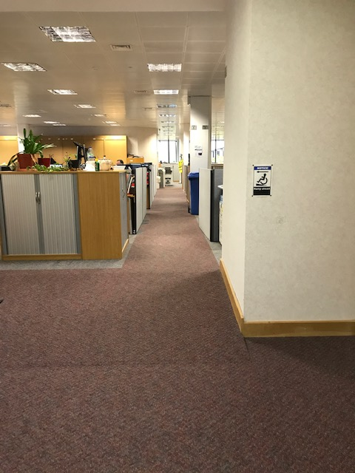

When entering the slope is visible and there is a warning sign.

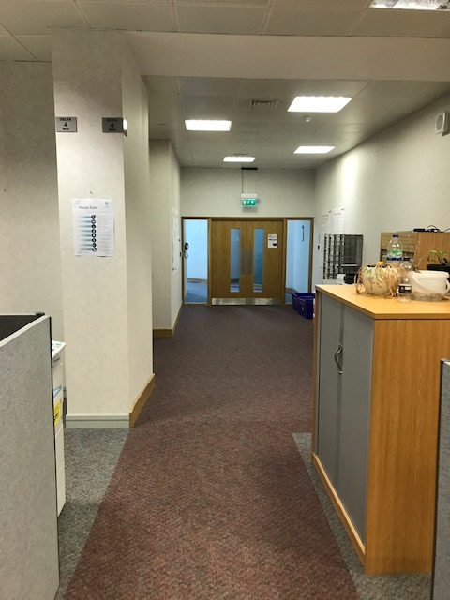

When leaving the office the ramp is hidden by lighting effect and there is no sign.